WEEK 7
9. ReactJS
ListOfPlayers.js
import React from 'react';

function ListOfPlayers() {
const players = [
{ name: "Virat", score: 85 },
{ name: "Rohit", score: 60 },
{ name: "Rahul", score: 45 },
{ name: "Jadeja", score: 95 },
{ name: "Pant", score: 78 },
{ name: "Dhoni", score: 120 },
{ name: "Shami", score: 25 },
{ name: "Bumrah", score: 72 },
{ name: "Ashwin", score: 38 },
{ name: "Iyer", score: 80 },
{ name: "Gill", score: 90 },
];

const filtered = players.filter(p => p.score < 70);

return (
<div>
<h2>All Players:</h2>
{players.map((p, i) => (
<p key={i}>{p.name} - {p.score}</p>
))}

<h3>Players with score below 70:</h3>
{filtered.map((p, i) => (
<p key={i}>{p.name} - {p.score}</p>
))}
</div>
);
}

export default ListOfPlayers;

IndianPlayers.js
import React from 'react';

function IndianPlayers() {
const T20 = ['Virat', 'Rohit', 'Pant', 'Hardik'];
const Ranji = ['Pujara', 'Rahane', 'Iyer'];

const merged = [...T20, ...Ranji];

const [first, second, ...rest] = merged;

return (
<div>
<h2>Odd & Even Team Players</h2>
<p>Odd: {first}</p>
<p>Even: {second}</p>
<p>Others: {rest.join(", ")}</p>
</div>
);
}

export default IndianPlayers;

App.js
import React from 'react';
import ListOfPlayers from './ListOfPlayers';
import IndianPlayers from './IndianPlayers';

function App() {
const flag = true;

return (
<div>
{flag ? <ListOfPlayers /> : <IndianPlayers />}
</div>
);
}

export default App;

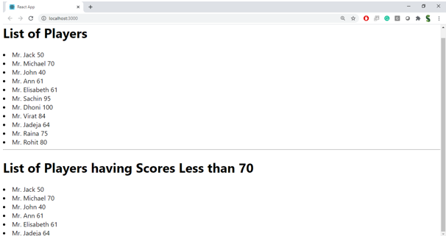
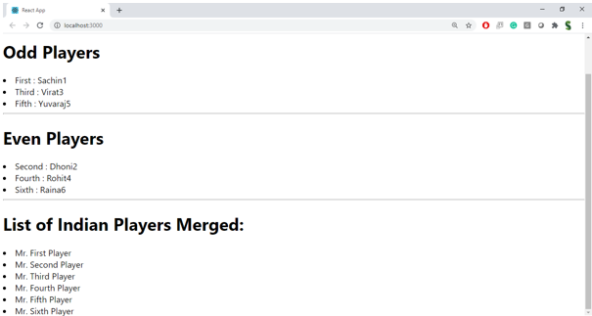

10. ReactJS
App.js
import React from 'react';

function App() {
const offices = [
{ name: "CozySpace", rent: 55000, address: "Chennai" },
{ name: "SmartOffice", rent: 75000, address: "Bangalore" },
{ name: "WorkNest", rent: 40000, address: "Hyderabad" }
];

return (
<div>
<h1 style={{ color: "navy" }}>Office Space Rental</h1>
<img src="https://via.placeholder.com/300x150" alt="Office" />

{offices.map((office, index) => (
<div key={index}>
<h2>{office.name}</h2>
<p>Address: {office.address}</p>
<p style={{ color: office.rent > 60000 ? "green" : "red" }}>
Rent: ₹{office.rent}
</p>
</div>
))}
</div>
);
}

export default App;

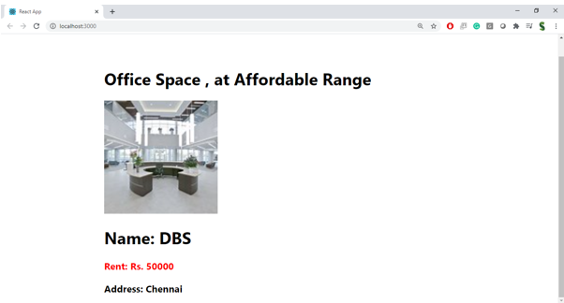

11. ReactJS
App.js
import React, { useState } from 'react';

function App() {
const [count, setCount] = useState(0);
const [rupees, setRupees] = useState("");
const [euro, setEuro] = useState("");

const increment = () => {
setCount(count + 1);
sayHello();
};

const decrement = () => {
setCount(count - 1);
};

const sayHello = () => {
alert("Hello! Button was clicked.");
};

const sayWelcome = (msg) => {
alert("Welcome message: " + msg);
};

const handleConvert = () => {
const result = (parseFloat(rupees) / 90).toFixed(2);
setEuro(result);
};

return (
<div>
<h2>Counter: {count}</h2>
<button onClick={increment}>Increment</button>
<button onClick={decrement}>Decrement</button>

<br /><br />
<button onClick={() => sayWelcome("Welcome to the Event Example!")}>Say Welcome</button>

<br /><br />
<button onClick={() => alert("I was clicked!")}>OnPress</button>

<br /><br />
<h2>Currency Converter</h2>
<input type="text" placeholder="INR" value={rupees} onChange={(e) => setRupees(e.target.value)} />
<button onClick={handleConvert}>Convert</button>
<p>In Euros: €{euro}</p>
</div>
);
}

export default App;

12. 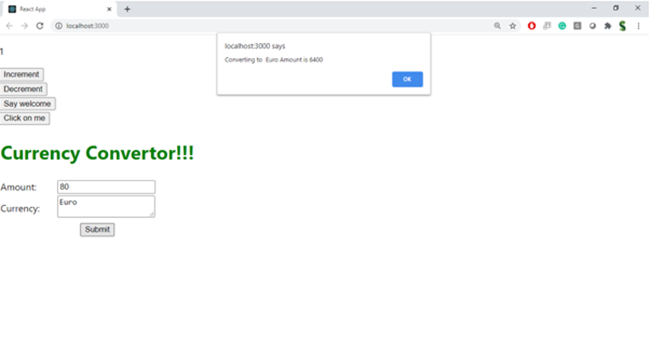
12. ReactJS
App.js
import React, { useState } from 'react';

function App() {
const [isLoggedIn, setIsLoggedIn] = useState(false);

const handleLogin = () => setIsLoggedIn(true);
const handleLogout = () => setIsLoggedIn(false);

return (
<div>
<h1>Flight Ticket Booking</h1>
{isLoggedIn ? (
<div>
<h2>Welcome, User!</h2>
<button onClick={handleLogout}>Logout</button>
<p>You can now book your flight tickets.</p>
</div>
) : (
<div>
<h2>Hello, Guest!</h2>
<button onClick={handleLogin}>Login</button>
<p>You can only view flight details.</p>
</div>
)}
</div>
);
}

export default App;

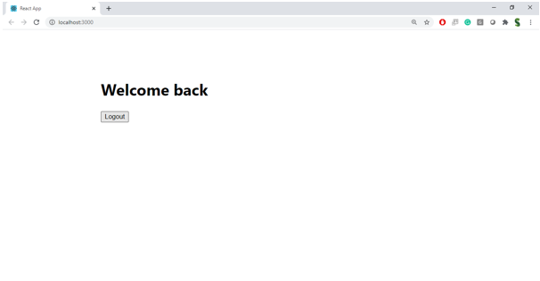
13. ReactJS
BookDetails.js
import React from 'react';
export default function BookDetails() {
return <h2>Book Details Component</h2>;
}

BlogDetails.js
import React from 'react';
export default function BlogDetails() {
return <h2>Blog Details Component</h2>;
}

CourseDetails.js
import React from 'react';
export default function CourseDetails() {
return <h2>Course Details Component</h2>;
}

App.js
import React, { useState } from 'react';
import BookDetails from './BookDetails';
import BlogDetails from './BlogDetails';
import CourseDetails from './CourseDetails';

function App() {
const [choice, setChoice] = useState("book");

return (
<div>
<h1>Blogger App</h1>
<button onClick={() => setChoice("book")}>Book</button>
<button onClick={() => setChoice("blog")}>Blog</button>
<button onClick={() => setChoice("course")}>Course</button>

{choice === "book" && <BookDetails />}
{choice === "blog" && <BlogDetails />}
{choice === "course" && <CourseDetails />}
</div>
);
}

export default App;

